Tomcat 7 Installation

1. Take one Ec2-instance (Amazon Linux (or)Redhat,(or)Ubuntu.
2. In this I am taking Ec2 Amazon Linux.
3. To install java8 please visit the below link and follow the steps as mentioned in that document.

<https://tecadmin.net/install-java-8-on-centos-rhel-and-fedora/>

1. First download the tomcat 7 by visiting the below link.

C:\Users\RAJESH\Desktop\tomcat7_1.PNG

1. After visiting the above link make sure you download tomcat7 zip version only

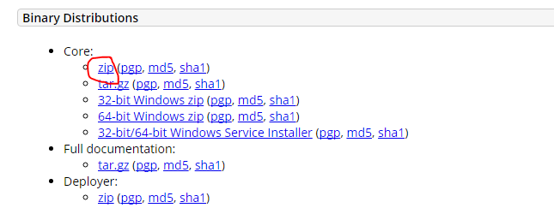

1. Copy the link address and by using wget paste it in ec2 instance.



7) Now one file will be downloaded, unzip the file.

8) After unzip the file pls move to apache directory, then in that directory you will see some files like this.

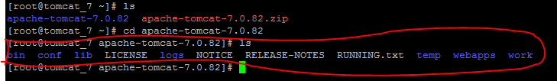

9) Now move to conf directory

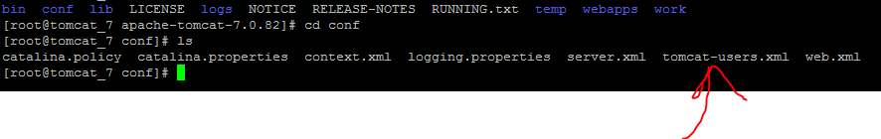

10) There is a file by name Tomcat-users.xml, pls open the file by using vi tomcat-users.xml



11) Remove all the content in tomcat-users.xml and paste the below content in that file.

<?xml version="1.0" encoding="UTF-8"?>

<tomcat-users>

  <role rolename="manager-gui"/>

  <role rolename="manager-script"/>

  <role rolename="manager-jmx"/>

  <role rolename="manager-status"/>

  <role rolename="admin-gui"/>

  <role rolename="admin-script"/>

  <user username="admin" password="admin" roles="manager-gui, manager-script, manager-jmx, manager-status, admin-gui, admin-script"/>

</tomcat-users>

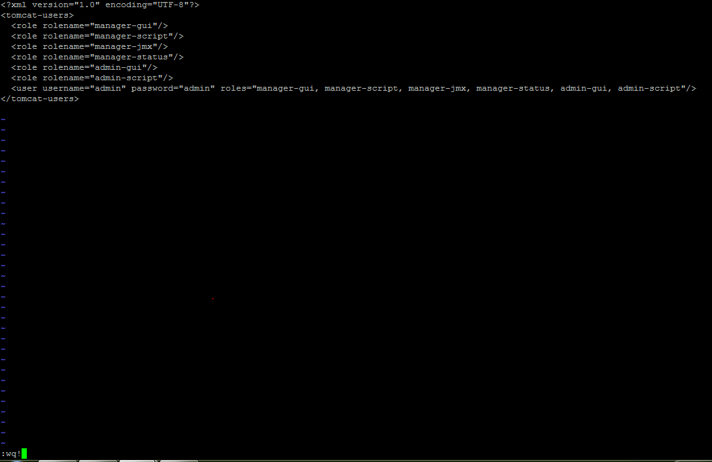

Save it.

12) Now move to bin directory and type ./catalina.sh start

In my case I got an error like permission denied so I gave 777 permissions

Chmod 777 catalina.sh

Service will be started

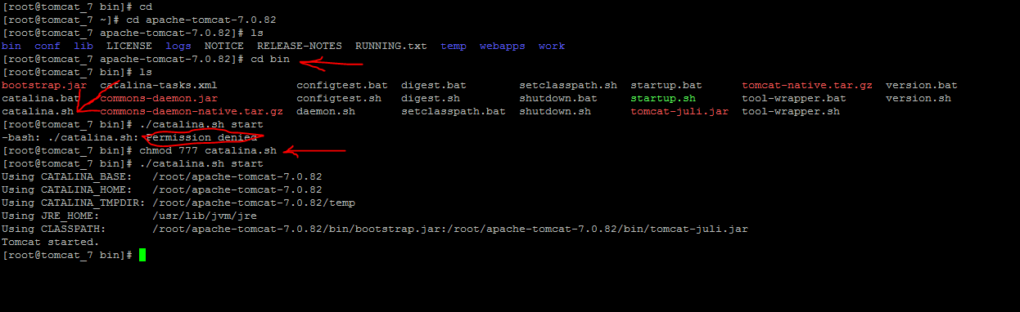

13) Make sure port number 8080 is open in security group

Open empty tab in Google chrome take the ip address of tomcat and paste:8080

In my case it is <http://13.127.102.117:8080/>

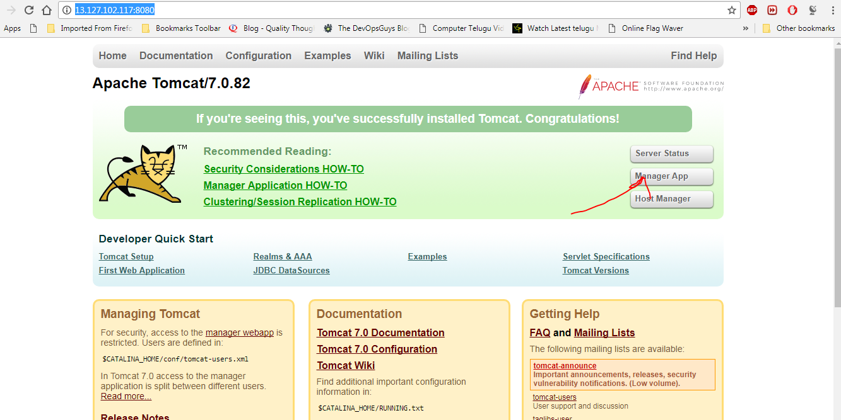

If above page is displayed then tomcat is installed successfully.

14) We created one user

Username: admin

Password: admin

At right-side click on Manager app enter credentials you will be redirected to different page where you can deploy your war file.

